Grad Tuition Structure Changes

LCB:
Dropped higher step-in credit (higher first credit cost) balanced to 3% increase at 9 credit hours (full time) for the following programs: MBA, MAcc. Matched MBA plateau to 16 credits (similar to all other programs except Law)

AY 23-24: AY 24-25
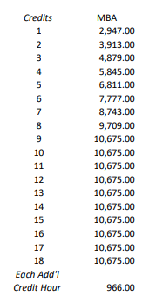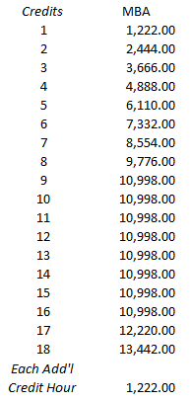

Summer Rate Changes:

LCB
MBA/MAcc dropped a higher step-in credit, but increased the per credit rate. This decreases the cost for students that are less than full time during the summer. At 9 credits it equals a 3% increase.

MBA
AY 23-24 AY 24-25
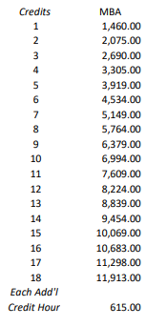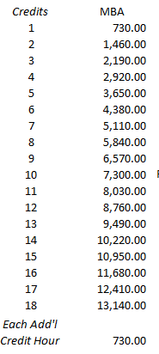

MAcc:
AY 23-24 AY 24-25
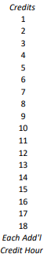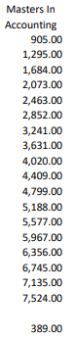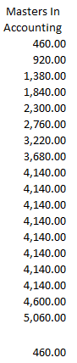

Business Doctoral Programs increased to match academic year rates.

SOJC
Media Studies Masters/Doctoral, Advertising and Brand Responsibility, and Graduate Multimedia programs dropped a higher step-in credit and at 9 credits is +1% to +1.6% to prior year summer.

AY 23-24 AY 24-25
