Peer Institutions

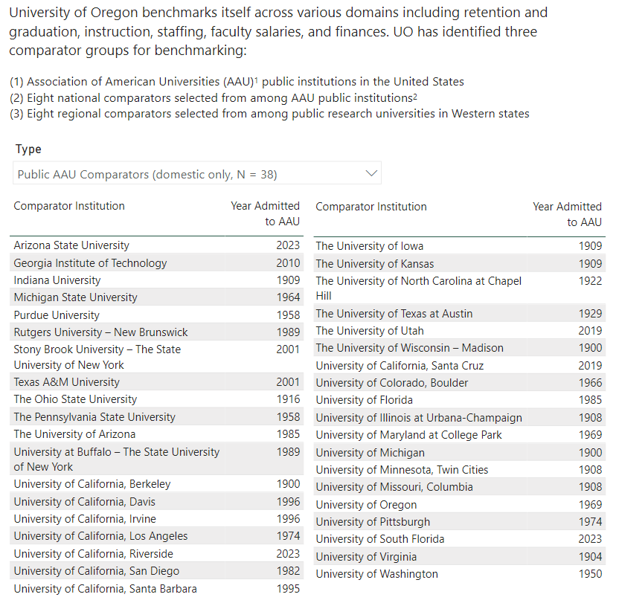

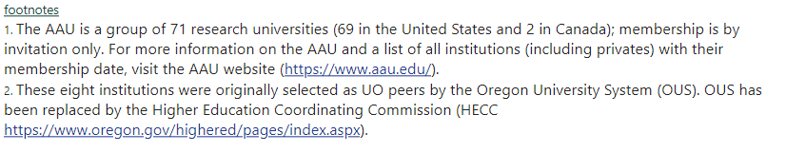

Source: <https://ir.uoregon.edu/uo-overview/peer-institutions>